Workplace Controls

The workplace must be reviewed to identify risks, find controls, and share information and training to employees on how they can protect themselves from COVID-19. The hierarchy of controls should be used to minimize risk: elimination, substitution, engineering controls, administrative controls, and PPE.
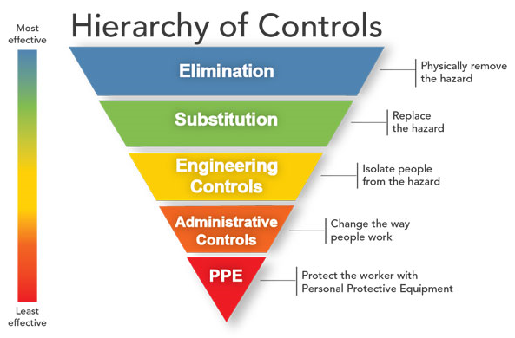

Figure 1 – Image from NIOSH Hierarchy of Controls (NIOSH, 2015)

These control measures should be put in place to prevent employees from getting sick with COVID-19.
- Elimination – Prevent sick or exposed employees and visitors from entering your workplace. People with symptoms such as fever, cough, and shortness of breath should stay home. People who have been around someone who is sick with COVID-19 should stay home. Have a plan so you know what to do if someone starts feeling sick at work.
- Engineering controls – Barriers and enclosures can be used to isolate employees from people who may be sick. HVAC systems should be inspected to be sure they are working right.
- Administrative controls – Stay 6’ away from other people. Limit the people in shared spaces like breakrooms by scheduling shifts and break times not to overlap. Have employees wash or sanitize their hands often. Clean and disinfect commonly touched surfaces. Use virtual communication instead of face-to-face meetings. Have employees work from home. Train employees on workplace hazards and how to protect themselves.
- PPE – People in healthcare working with sick people should use N95s or other air-purifying respirators. Wear gloves to protect your hands from cleaning products. Safety glasses, face masks, and face shields should be used if people can’t stay 6’ apart.
A note about homemade face coverings. Homemade cloth face coverings are not PPE. Wearing face covering will not protect the wearer from inhaling small droplets that could contain coronavirus. Face coverings can prevent a sick person from spreading germs so it’s recommended that everyone wear one when out in public in case they are sick but don’t know. Try to stay 6’ away from people even when wearing a face covering.
Resources
Back to Work Safely™
American Society of Heating, Refrigerating and Air-Conditioning Engineers (ASHRAE) – COVID-19 Preparedness Resources
OSHA – Guidance on Preparing Workplaces for COVID-19
CDC -- Guidance on Cloth Face Coverings
EPA – List N: Disinfectants for Use Against SARS-CoV-2

